3 Tables : City, Customer, Country

COUNTRY Table :

* ***CREATE TABLE*** Country (

id INT ***PRIMARY KEY AUTO_INCREMENT***,

country_name **VARCHAR**(25),

country_name_eng **VARCHAR**(25),

country_code **VARCHAR**(10)

);



* ***INSERT INTO*** Country (country_name, country_name_eng, country_code) ***VALUES***

("Deutschland", "Germany", "DEU"),

("Srbija", "Serbia", "SRB"),

("Hrvatska", "Croatia", "HRV"),

("United States of America", "United States of America", "USA"),

("Polska", "Poland", "POL"),

("Espana", "Spain", "ESP"),

("Rossiya", "Russia", "RUS");

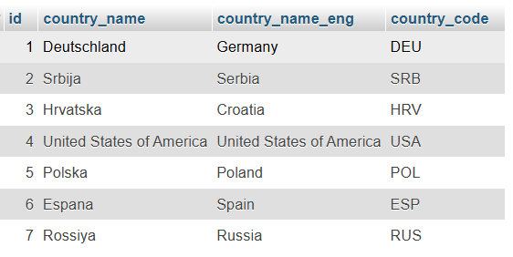

CiTY Table :

* ***CREATE TABLE*** City (

id **INT** ***PRIMARY KEY AUTO_INCREMENT***,

city_name **VARCHAR**(25),

lat **DECIMAL**(9,6),

long_ **DECIMAL**(9,6),

country_id **INT**,

***FOREIGN KEY*** (country_id) ***REFERENCES*** Country(id)

);



* ***INSERT INTO*** City (city_name, lat, long_, country_id) ***VALUES***

("Berlin", 52.520008, 13.404954, 1),

("Belgrade", 44.787197, 20.457273, 2),

("Zagreb", 45.815399, 15.966568, 3),

("New York", 40.730610, -73.935242, 4),

("Los Angeles", 34.052235, -118.243683, 4),

("Warsaw", 52.237049, 21.017532, 5);

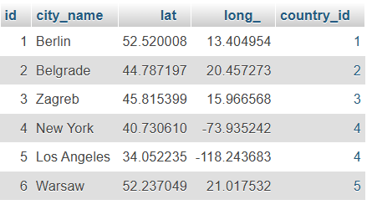

Customer Table :

* ***CREATE TABLE*** Customer (

id **INT** ***PRIMARY KEY AUTO_INCREMENT***,

customer_name **VARCHAR**(25),

city_id **INT**,

customer_address **VARCHAR**(25),

next_call_date **DATE**,

ts_inserted **DATETIME**,

***FOREIGN KEY*** (city_id) ***REFERENCES*** City(id)

);



* ***INSERT INTO*** Customer (customer_name, city_id, customer_address, next_call_date, ts_inserted) ***VALUES***

("Jewelry Store", 4, "Long Street 120", "2020-01-21", "2020-01-09 14:01:20.000"),

("Bakery", 1, "Kurfurstendamm 25", "2020-02-21", "2020-01-09 17:52:15.000"),

("Cafe", 1, "Tauentzienstrabe 44", "2020-01-21", "2020-01-10 08:02:49.000"),

("Restaurant", 3, "Ulica lipa 15", "2020-01-21", "2020-01-10 09:20:21.000");

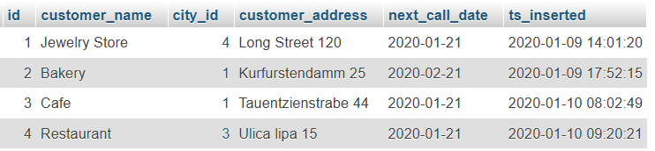

Task 1 :

(join multiple tables using left join)

* List all Countries and customers related to these countries.
* For each country displaying its name in english, the name of the city customer is located in as well as the name of the customer.
* Return even countries without related cities and customers.
* ***SELECT***

Country.country_name_eng,

City.city_name,

Customer.customer_name

***FROM*** Country

***LEFT JOIN*** City ***ON*** Country.id = City.country_id

***LEFT JOIN*** Customer ***ON*** City.id = Customer.city_id;

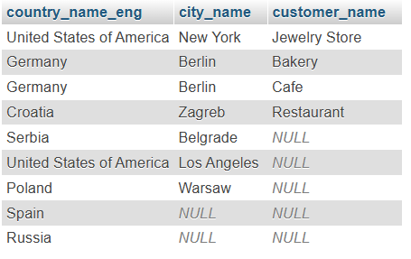

Task 2:

(Join multiple table using both left and inner join)

* Return the list of all countries that have pairs(exclude countries which are not referenced by any city). For such pairs return all customers.
* Return even pairs of not having a single customer.
* ***SELECT*** country.country_name, city.city_name, customer.customer_name

***FROM*** Country

***INNER JOIN*** City ***ON*** country.ID = city.country_id

***LEFT JOIN*** Customer ***ON*** city.id = customer.city_id;

